**Epilepsy12**

Since 2009 RCPCH has delivered ‘Epilepsy12’, the national clinical audit of seizures and epilepsies for children and young people as part of the National Clinical Audit and Patient Outcomes Programme (NCAPOP).

The clinical audit collects data when children and young people are first referred and assessed following an initial seizure, and follows their care for 12 months. They are grouped into 12 month cohorts, and so far there have been around 25k patients registered in the current round of Epilepsy12 (2018-21). Patients are registered to either an NHS Trust (England), or NHS Health Board (Wales). The funding for this project is coming via NHS England, so the API work will focus on NHS Trusts.

Patients can be registered by either an EEG service, or by the paediatric epilepsy team. There are then three stages of data collection: (1) Registration*, (2) Record of first assessment, and (2) Record of first year of care*. These are designed to be at the (1) at the point of referral (2) initial appointment after referral (3) the same form is then repeated to capture the rest of care/diagnosis over the following 12 months.

All the data in Epilepsy12 is inputted into our online data platform by the clinical team or admin support in the Trust/Health Board. Currently data can be entered either over the course of care, or retrospectively. The data entry takes a lot of time, and (increasingly) duplicates information teams are entering into their patient electronic health records.

Unlike some other health conditions, there is not a standard application or applications used for paediatric epilepsy. Data is recorded in Trust patient records, and the forms/systems used by Trusts vary. Therefore we’d be looking to identify a minimum standard dataset that could be extracted, a specification of required data fields for Trusts willing/able to adapt their record template, and the data fed into the relevant records held on the Epilepsy12 data platform (ideally via RCPCH, in case the Epilepsy12 platform provider changes in future).

The dataset and key measures were designed against NICE standards and guidelines, but the measures aren’t linked - and don’t map - to published NHS/ONS/PHE datasets.

We want to reduce the data entry burden on clinicians, improve the data completeness of Epilepsy12, and be able to provide closer to real-time reporting. The scope of the project NHS England are funding would be to:

* Use the audit dataset and stakeholder input to develop a data specification/transfer schema
* Secure CAG amendment / other necessary security approvals for changes to un-consented patient data processing and/or storage of identifiable data
* Work with a Trust or small group of Trusts to develop and test a data flow
* Develop an opensource API/transfer schema that is available and can be applied by other Trusts.

Longer term - beyond this project - we would want to expand data extraction across the other Trust(s) and into Wales. We would also hope to continue to build on the initial data flow; e.g. to develop links to other sources (such as HES), explore text recognition (as things like medications and investigations are often free text in records), include the Epilepsy12 organisational audit dataset, and have patient-facing elements.

*Registration and the First Year of Care would be the areas to focus on. Registration is how we identify eligible patients, and the first year of care form is the main source for our analysis and audit reporting.

**Current dataflow**

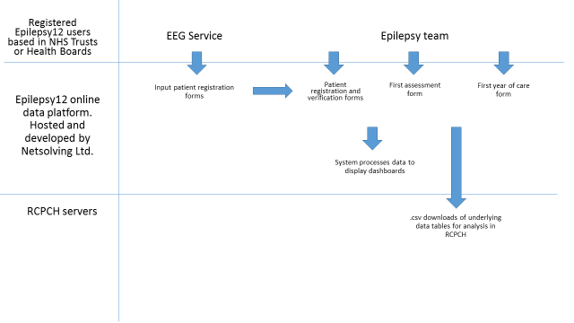

The Epilepsy12 data platform splits each audit form into tabs. I’ve pasted screen shots below to show these. We collect a lot of dates which may be a place to focus data extraction on; these record key professional input into care and investigations/services provided.

The underlying structure of the data platform follows these tabs, broadly at least. Most tabs are stored as a table. We have some basic reporting functions built into that platform (dashboards with case numbers etc). However we extract the different tables in csv form, then build/clean a dataset to complete analysis for the audit outside of the data platform.

**Registration and verification form**.

EEG services can complete tab 1; epilepsy teams can complete tab 2 to accept patients registered by EEG. Or, epilepsy teams complete tabs 1 and 2 to register a patient directly.

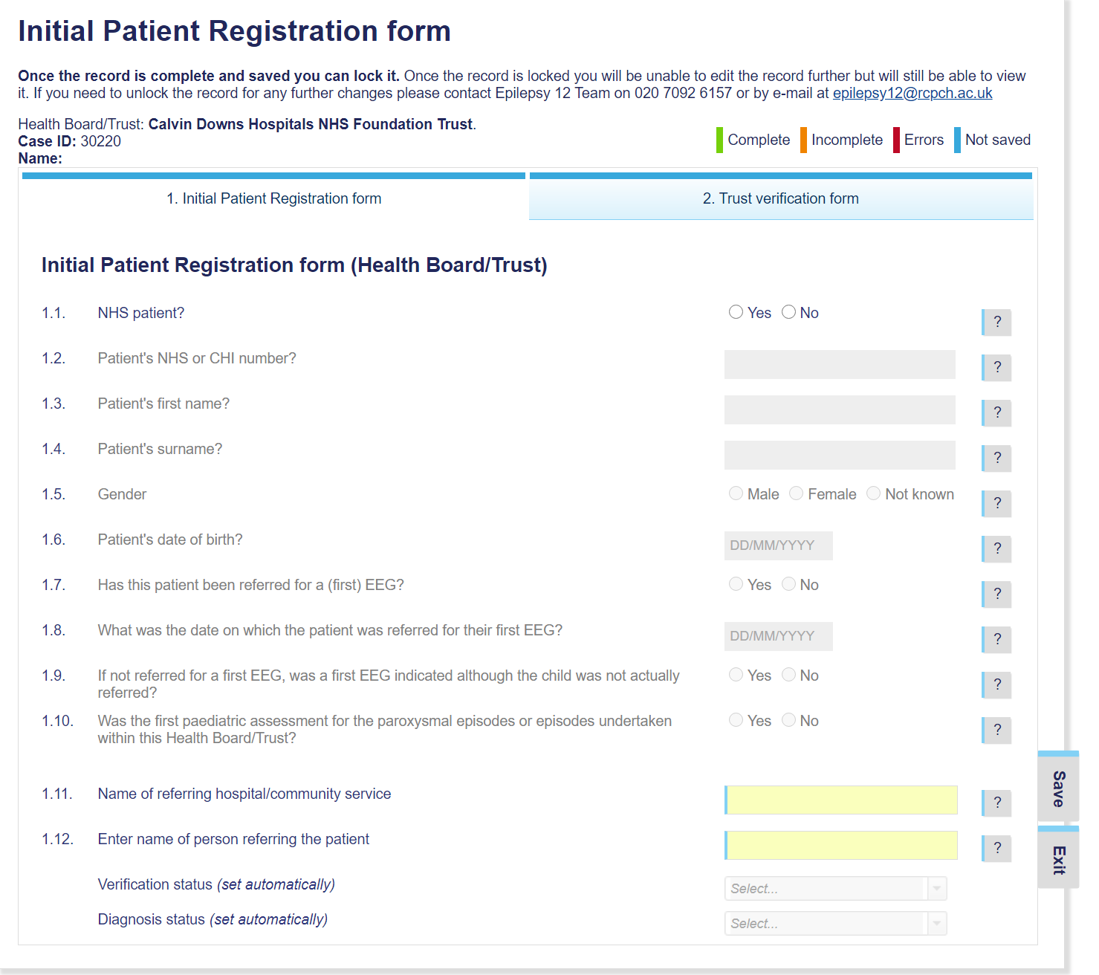

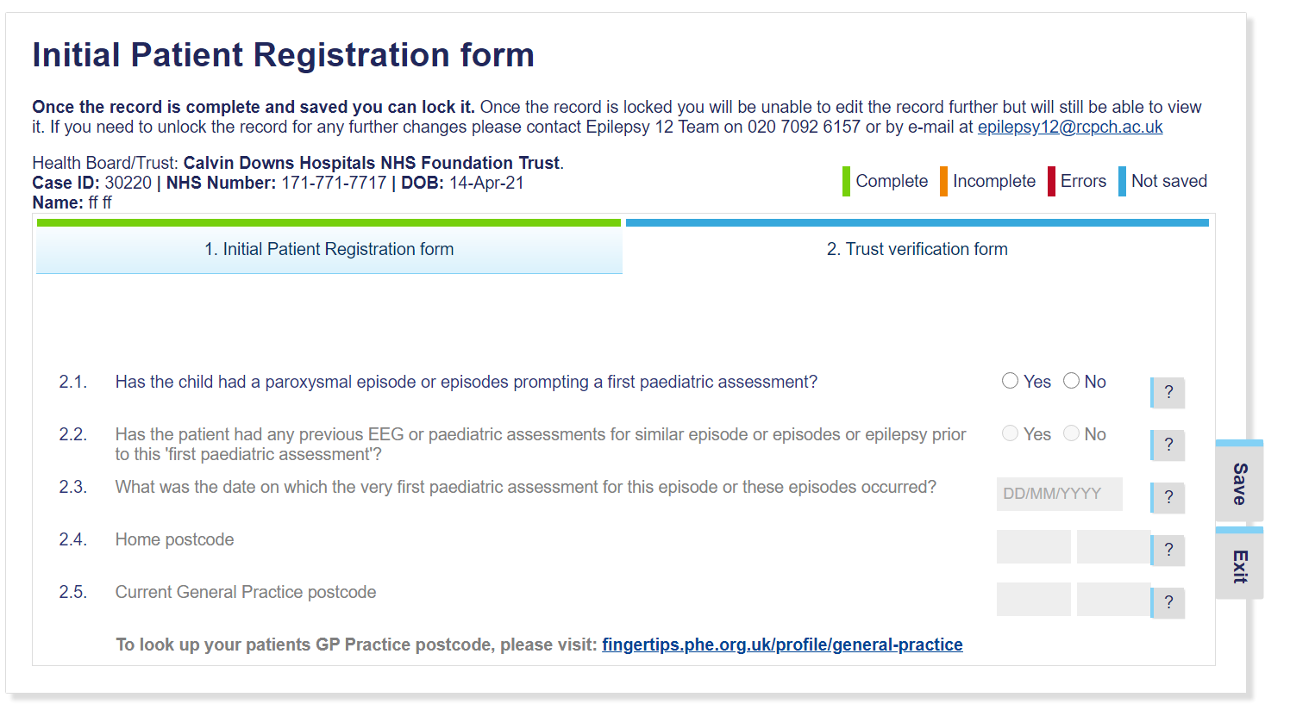

**First Assessment / First Year of Care form**

The same fields are used for both stages. The system currently pulls data entered in the first assessment form into the second form so it can be reviewed and updated for care provided over the whole 12 months. However, our analysis is only using a small set of the fields in the first assessment form, so we plan to reduce this and focus on the first year of care form.

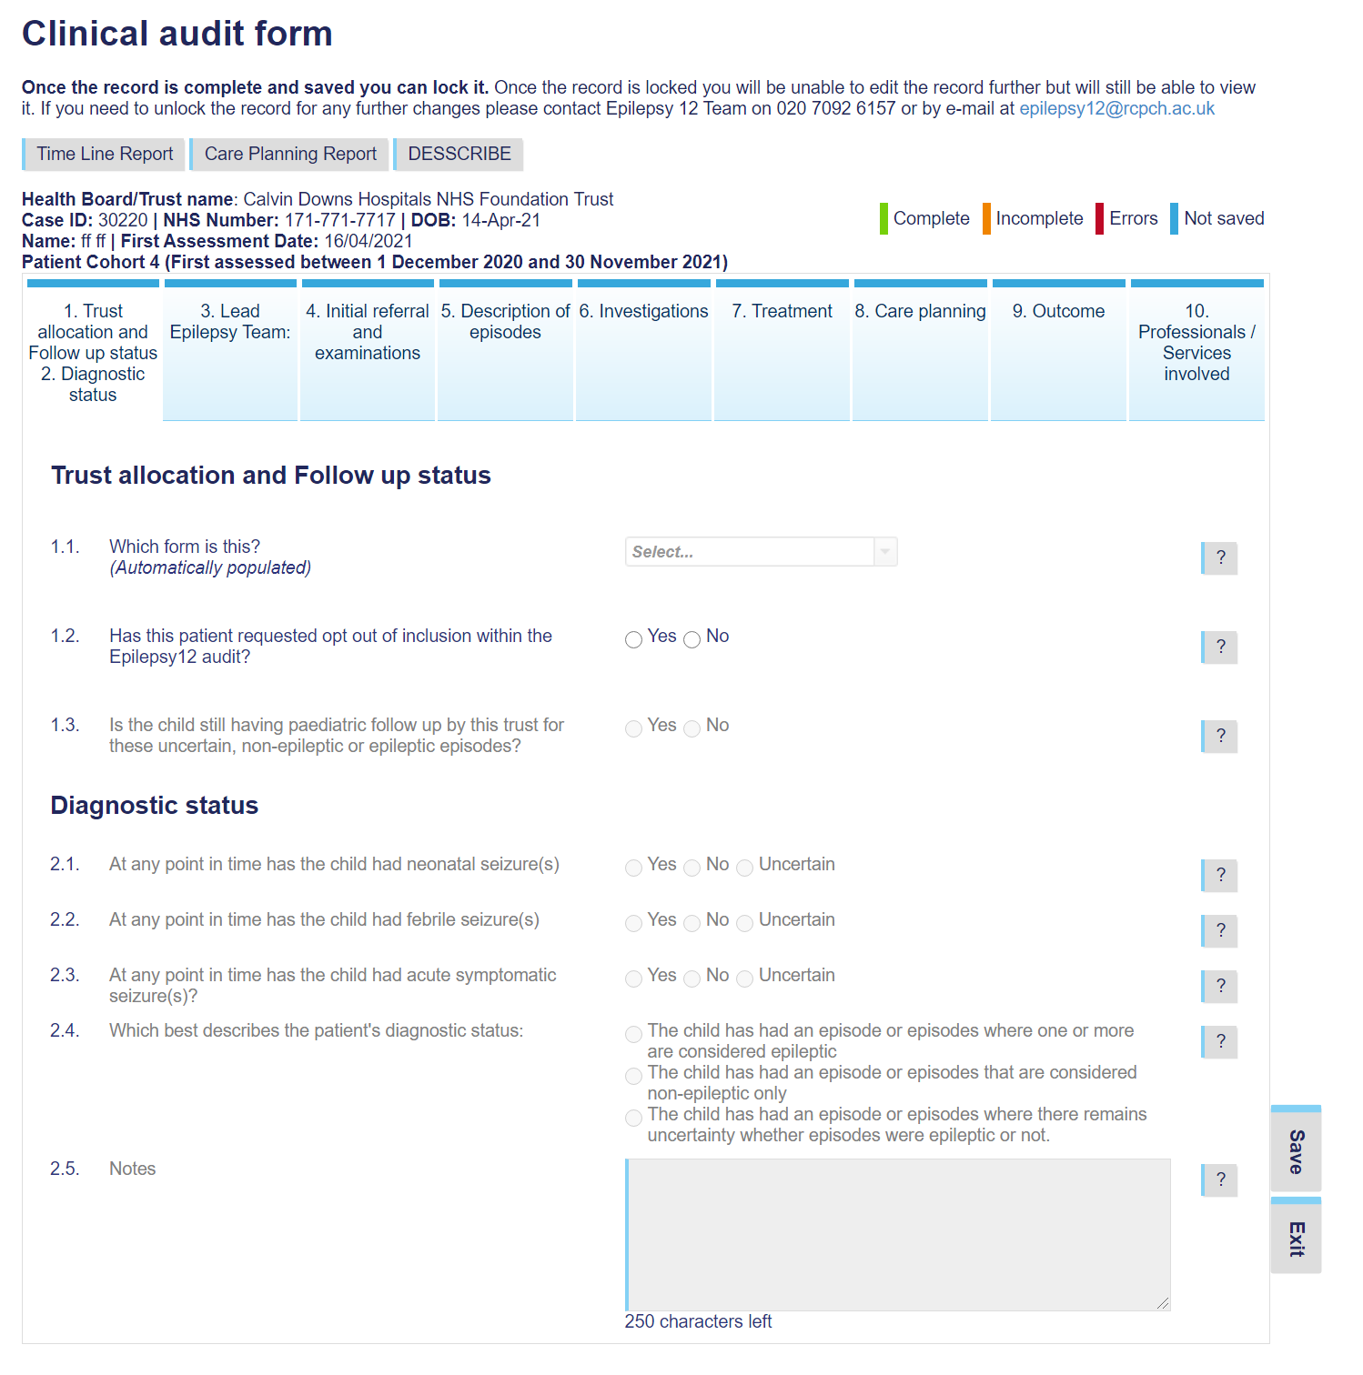

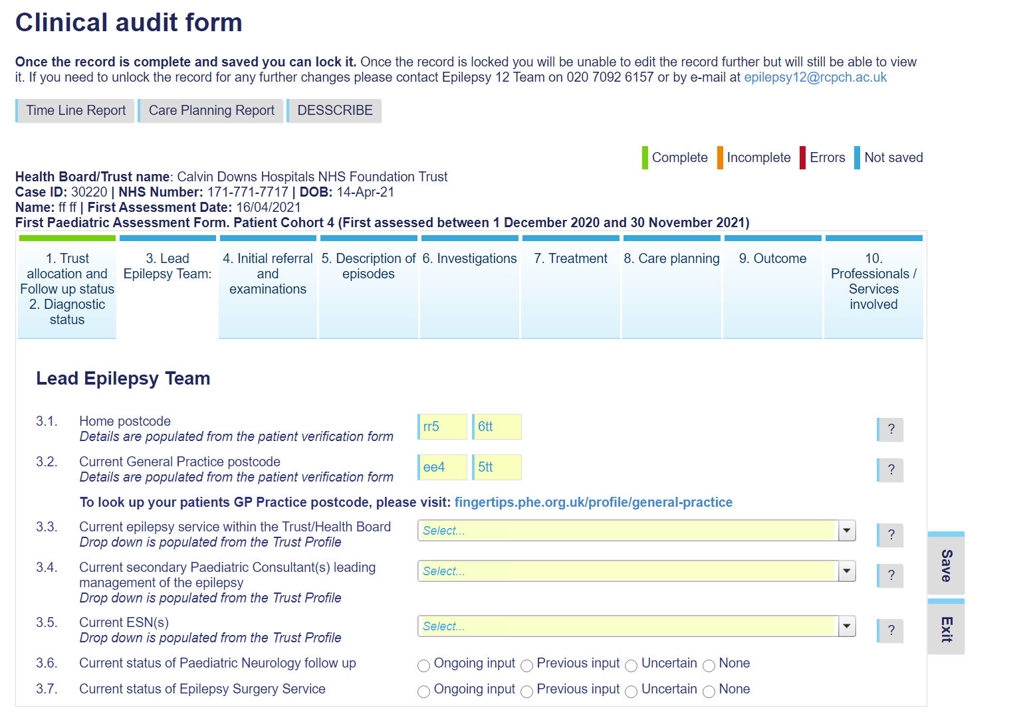

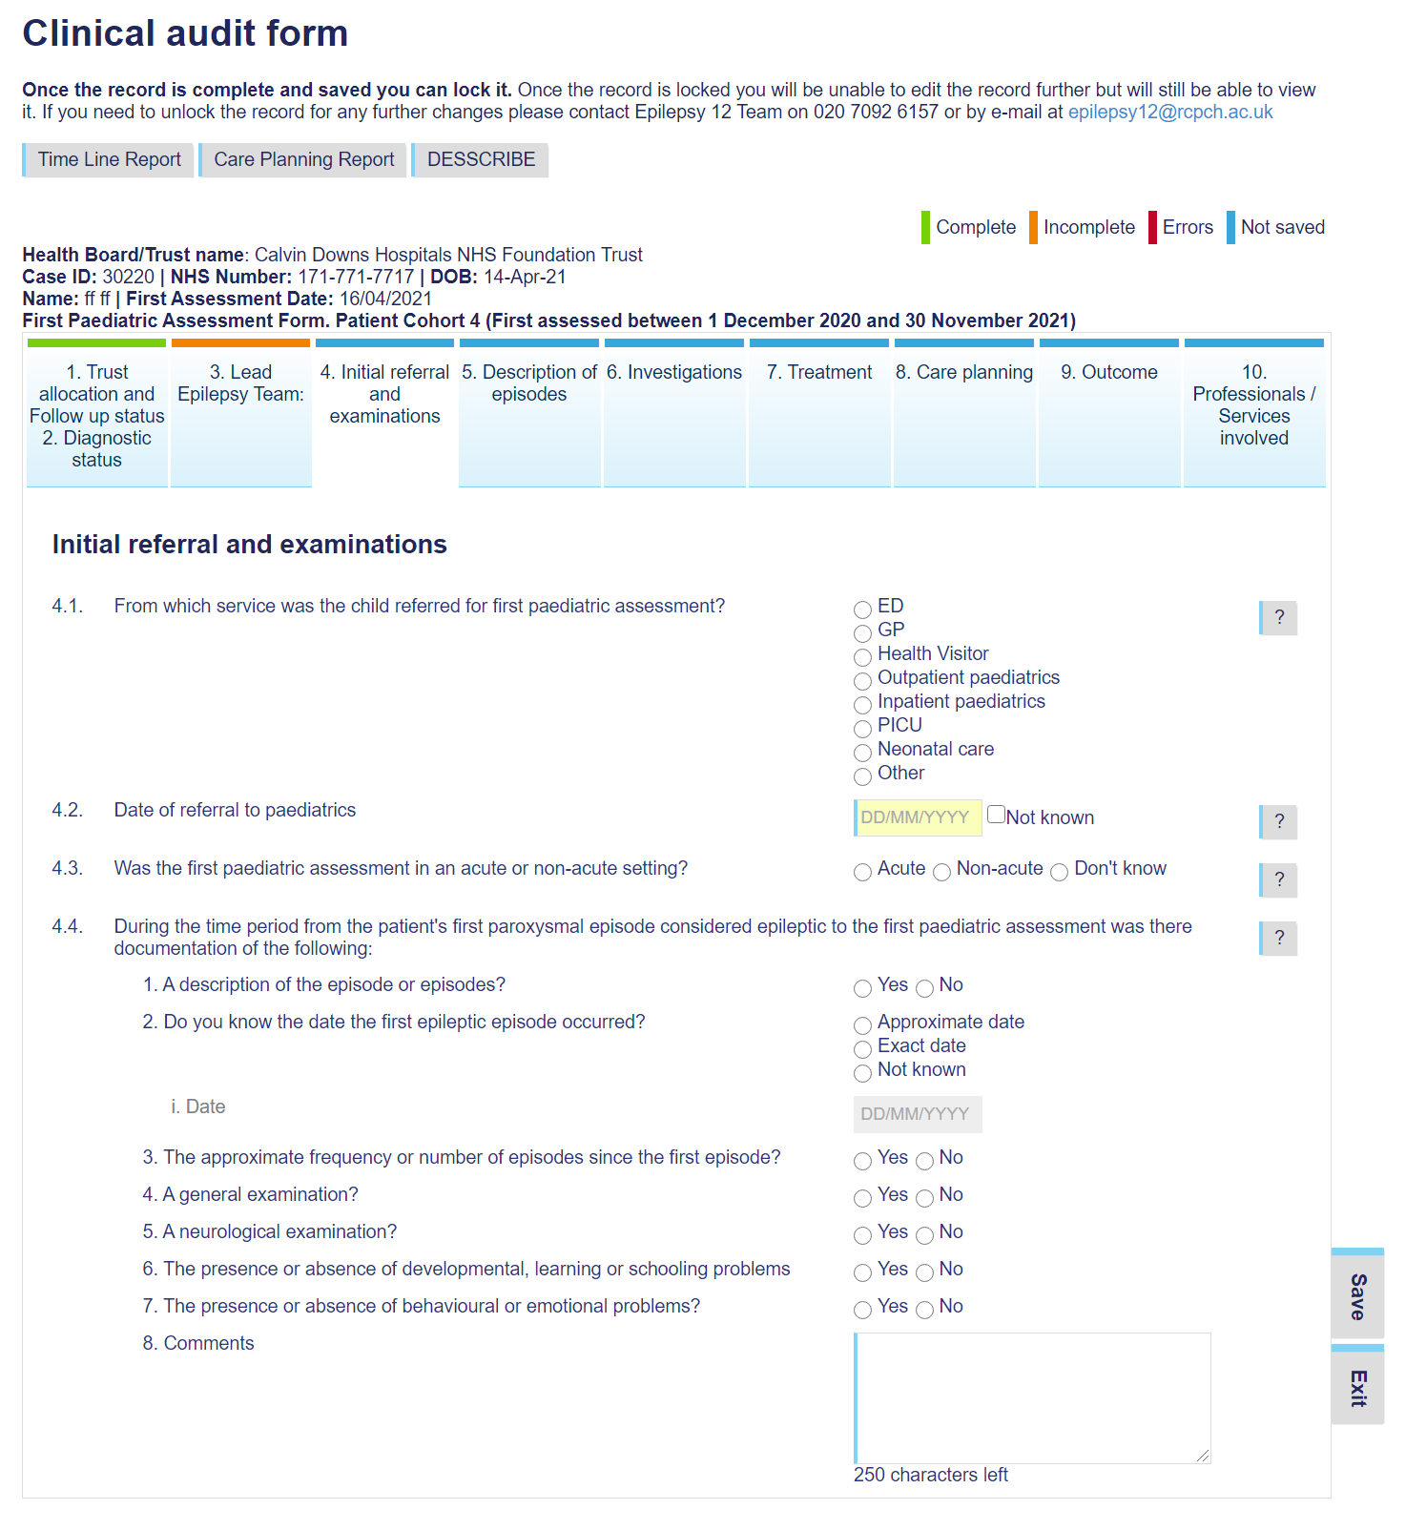

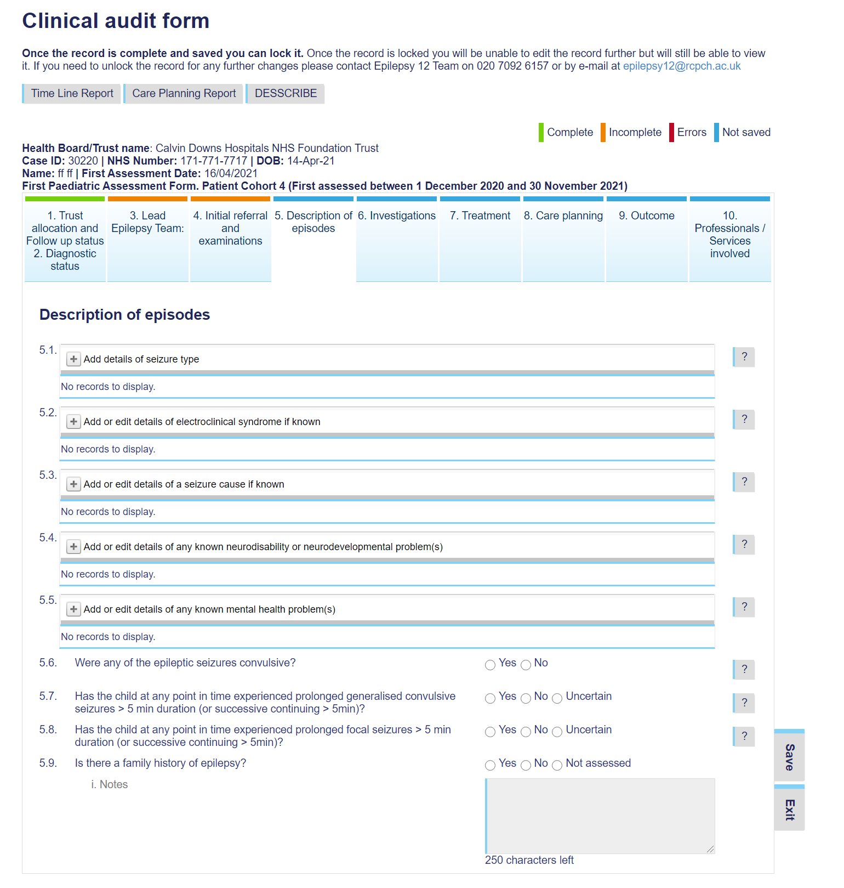

NB. 5.1, 5.2, 5.3, 5.4, 5.5 all expand. They are each stored as separate tables in the system.

E.g. for 5.1:

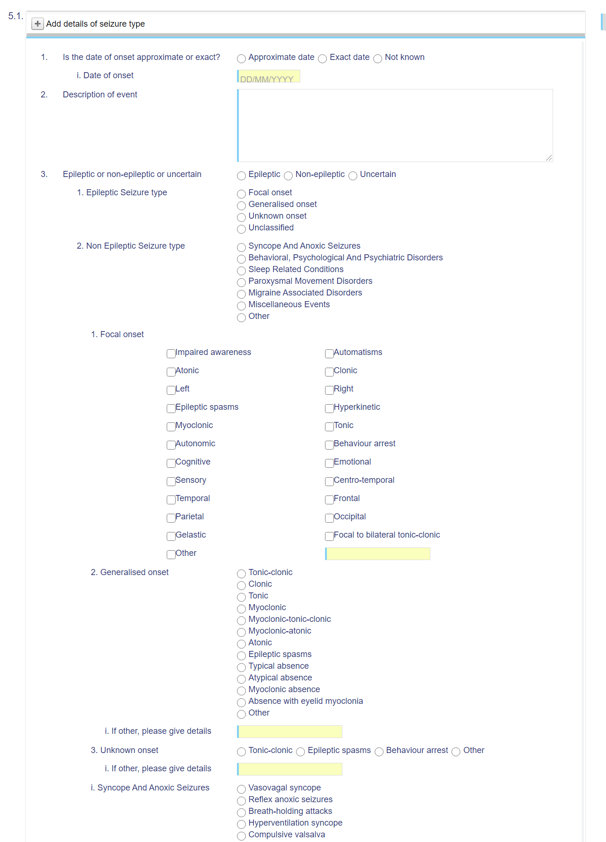

And 5.2:

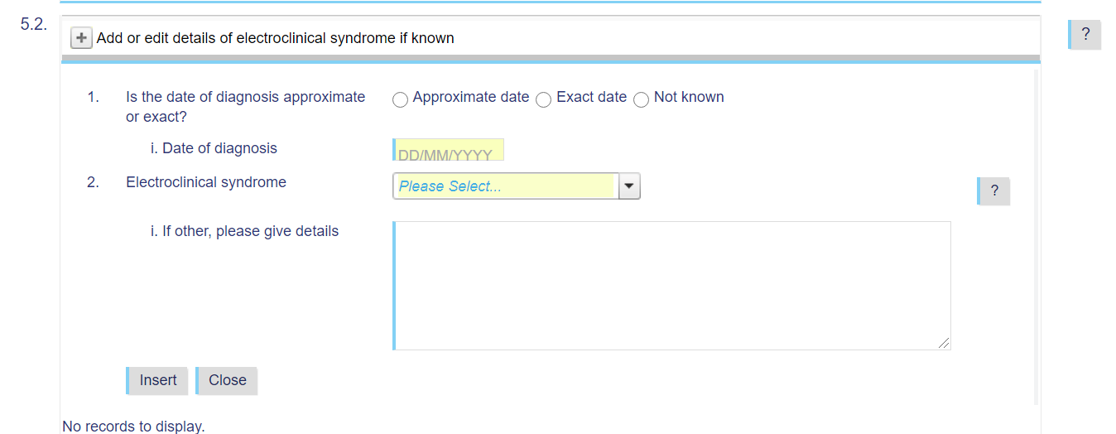

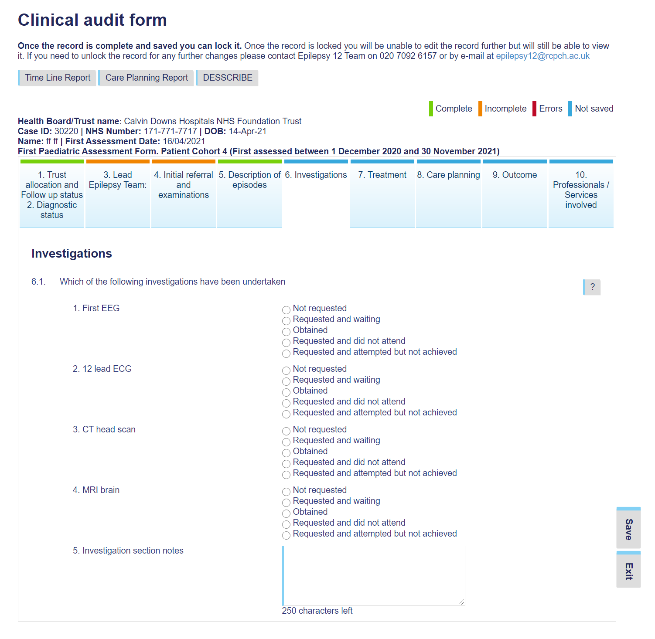

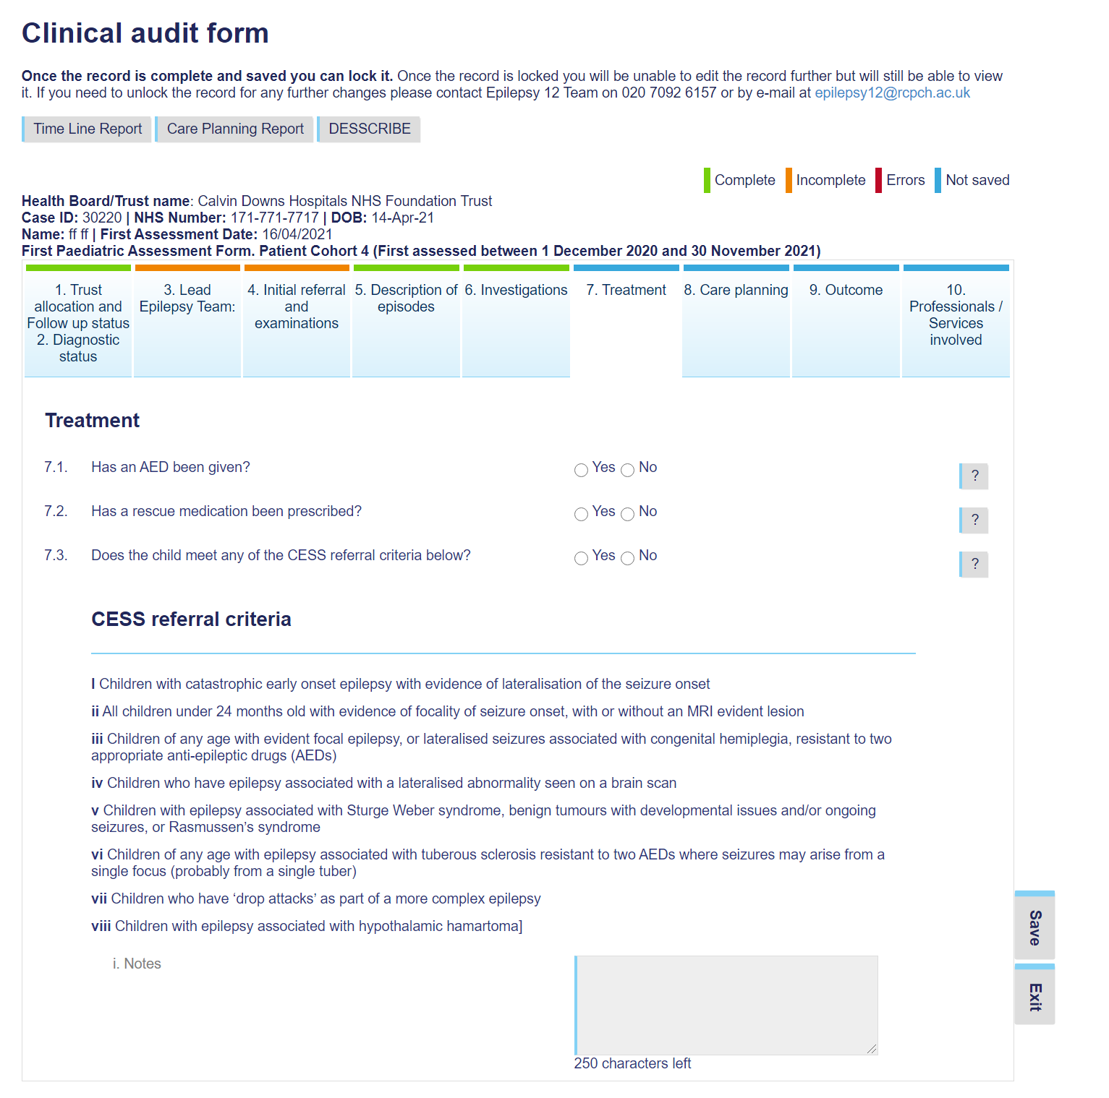

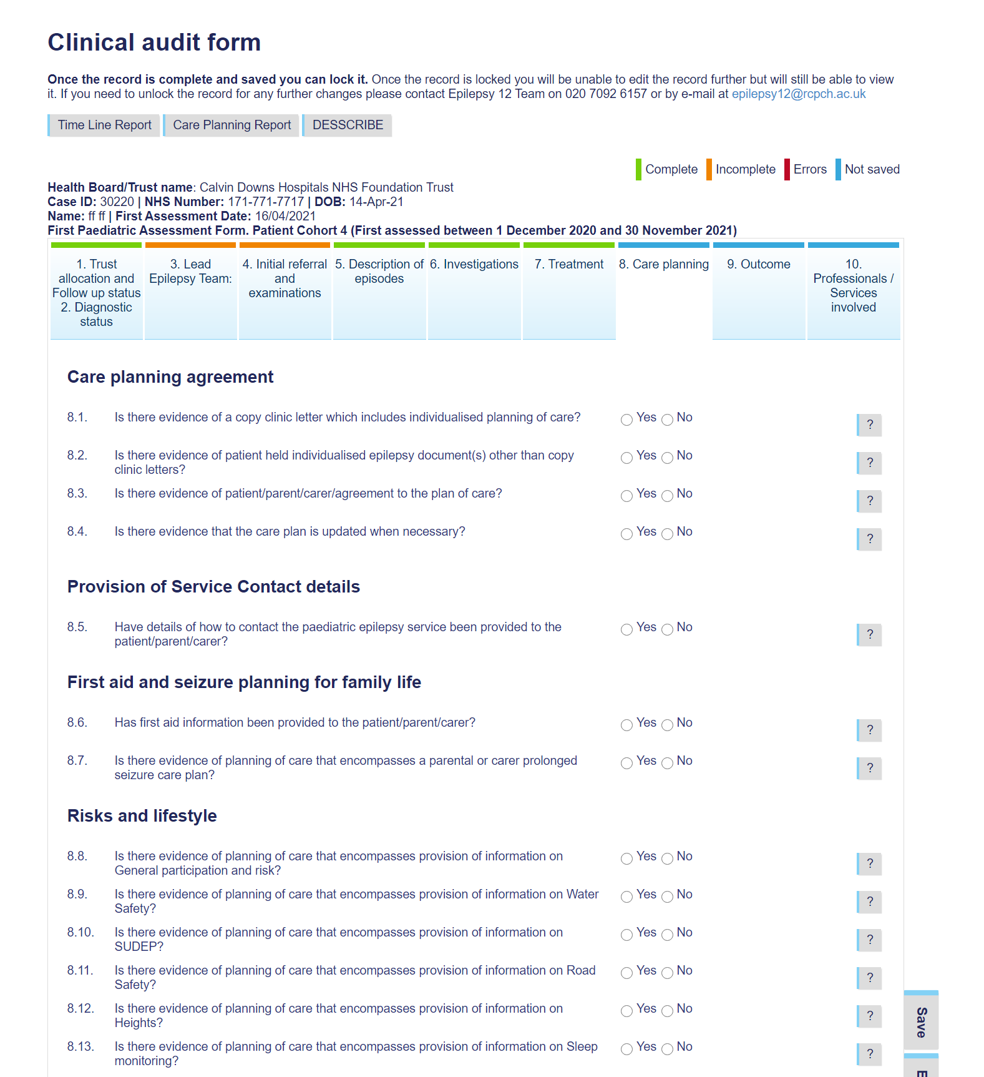

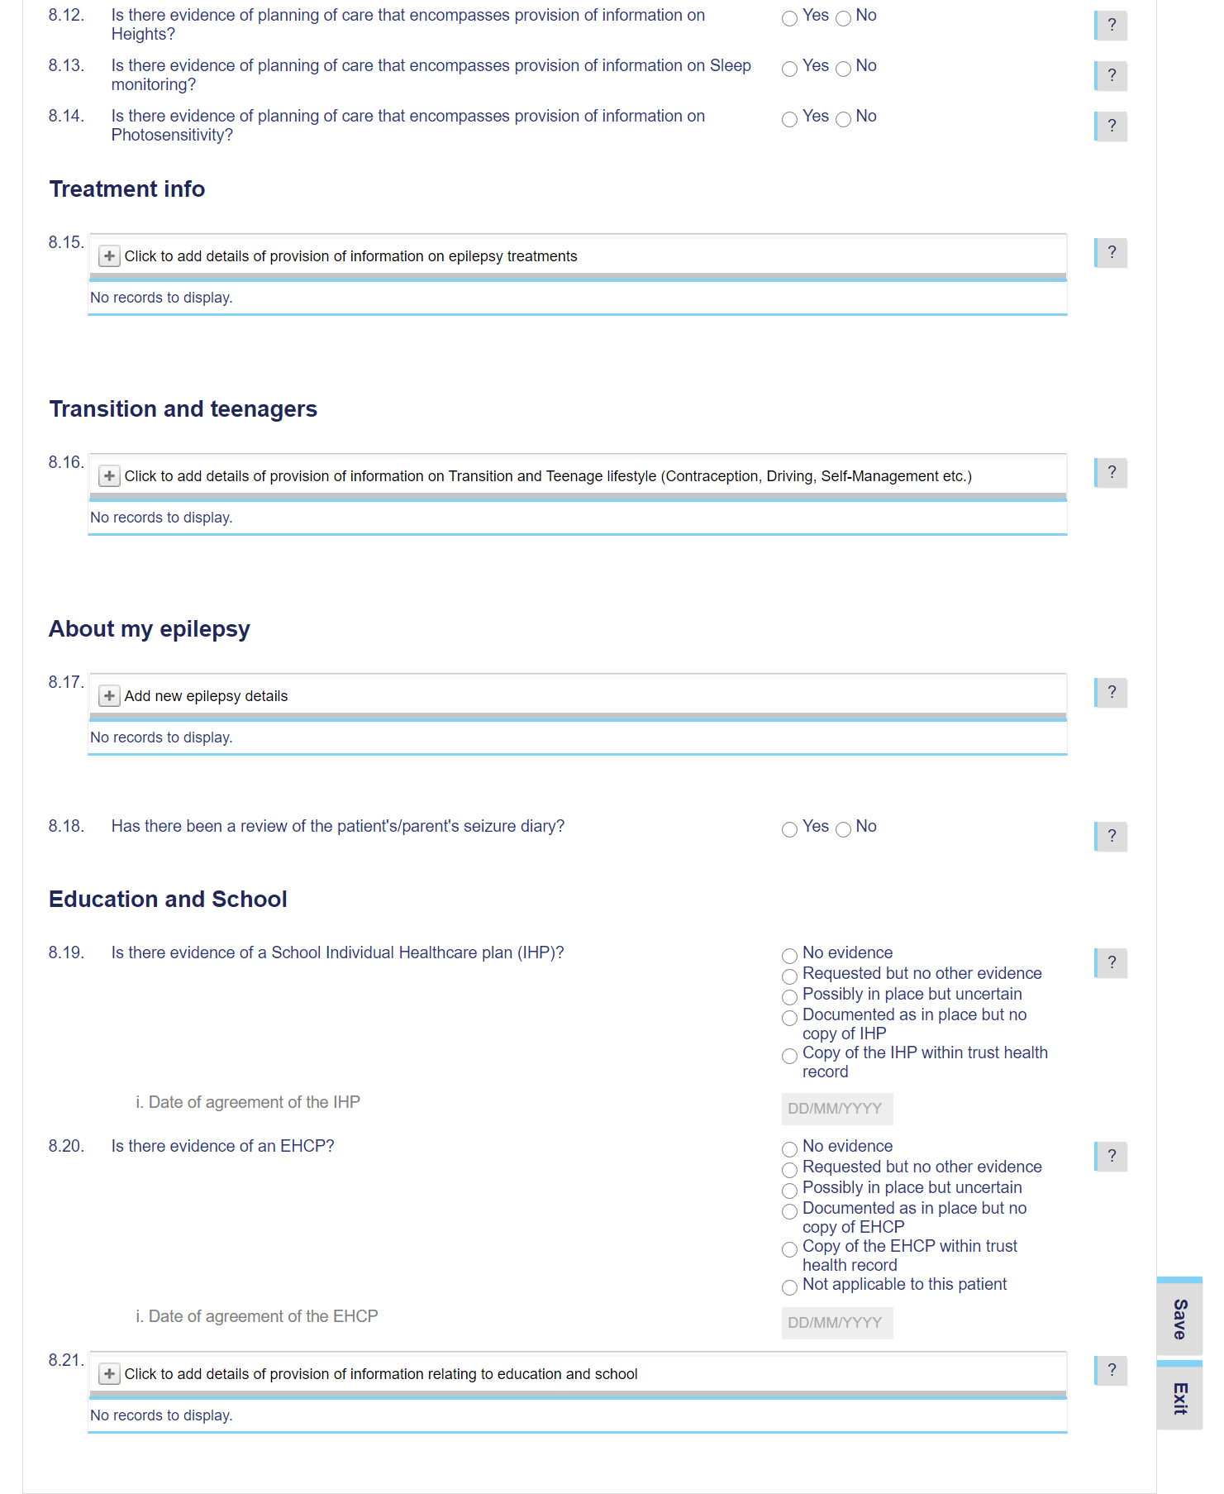

NB. 8.15, 8.16, 8.21 expand and are stored as separate tables by the system.

